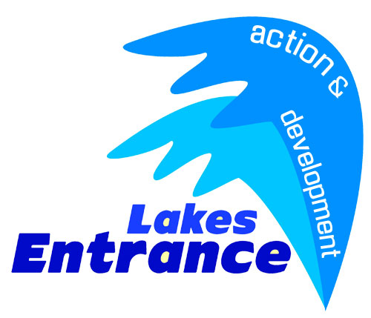

Lakes Entrance Fireworks Pledge Form – New Years Eve 2016

Name: ____________________________________________________________

Postal Address: _____________________________________________________

__________________________________________P/Code: _________________

Mobile Number: ______________________________

Email: ____________________________________________________________

I (We) pledge a total of $ __________ to be paid: __now __ on ____/____/2016.

I (We) plan to make this contribution in the form of: ___Cash ___Cheque ___Direct Debit

Acknowledgement Information:

Please use the following name(s) in all acknowledgements:

_____________________________________________________________________

Signature(s): _______________________________________ Date: _____________

**Please make cheques payable to:**

LEADA Activities Account

**Bank Details:**

LEADA Activities Account

BSB: 633 000

Account #: 154865729

A tax invoice will be mailed/emailed to you at date requested above.